Test Data

Methods

INSERT INTO account(Account_type, username, password)

VALUES ('planner','planner1','asd')

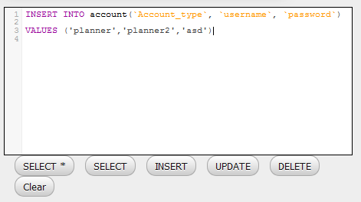

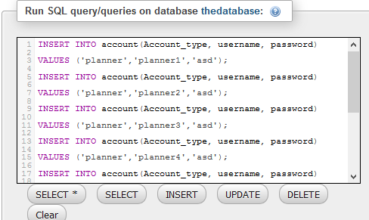

Full Query

INSERT INTO account(Account_type, username, password)

VALUES ('planner','planner1','asd');

INSERT INTO account(Account_type, username, password)

VALUES ('planner','planner2','asd');

INSERT INTO account(Account_type, username, password)

VALUES ('planner','planner3','asd');

INSERT INTO account(Account_type, username, password)

VALUES ('planner','planner4','asd');

INSERT INTO account(Account_type, username, password)

VALUES ('planner','planner5','asd');

INSERT INTO account(Account_type, username, password)

VALUES ('planner','planner6','asd');

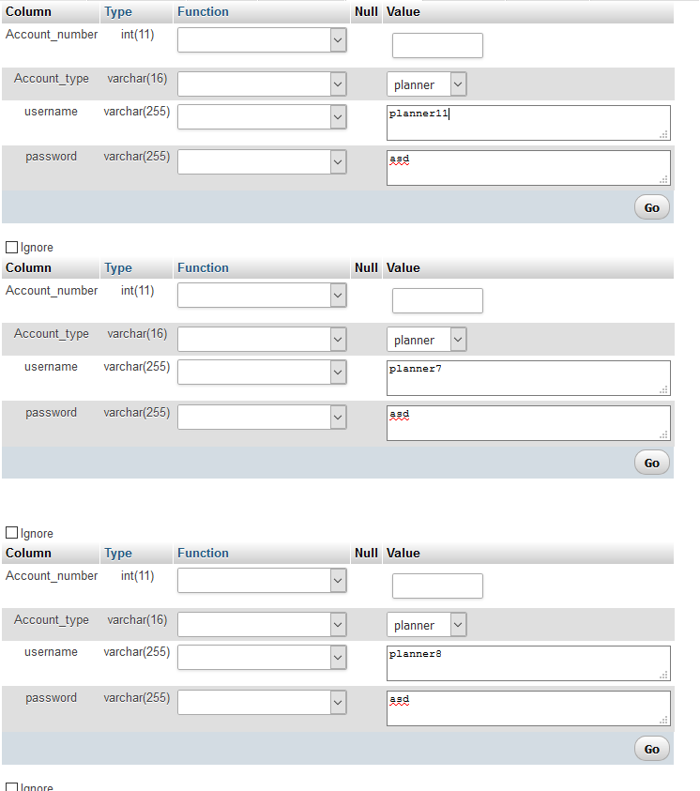

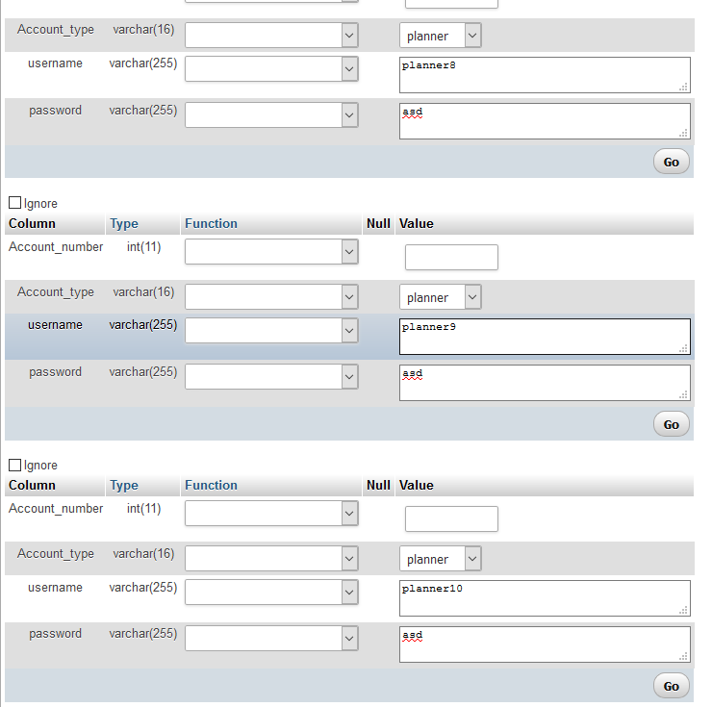

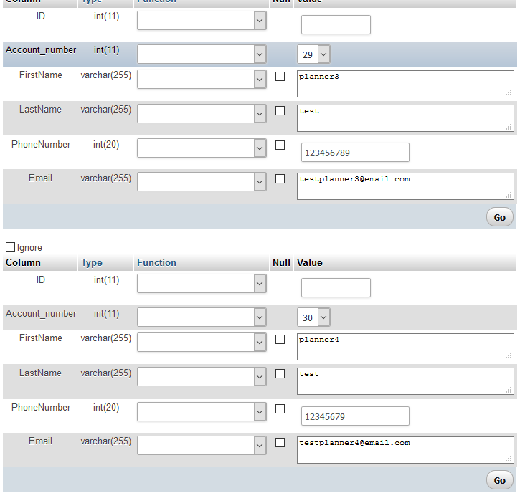

INSERT INTO planner(`Account_number`,`FirstName`,`LastName`,`PhoneNumber`,`Email`)

VALUES ('31','planner5', 'test', '12345679', 'testplanner4@email.com')

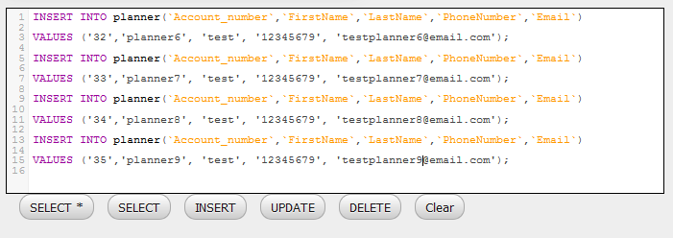

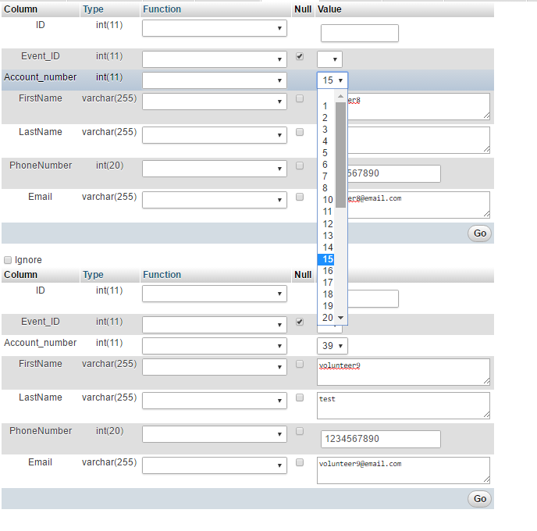

INSERT INTO attending_events(‘EVENT_ID’, ‘ID_number’, ‘Reserved_tickets’)

VALUES ( ‘1’,’13’,’5’)

